**Session 9: Hypothesis testing**

1. **The concept of normal distribution**
2. **What is a Normal Distribution?**

* **Shape:** The normal distribution looks like a bell-shaped curve.
* **Symmetry:** It is perfectly symmetrical around the center.

1. **Key Characteristics:**

* **Mean (Average):** The center of the curve.
* **Standard Deviation:** Measures the spread of the data.
  + 68.2% of the data falls within 1 standard deviation of the mean.
  + 95.4% falls within 2 standard deviations.
  + 99.7% falls within 3 standard deviations.

1. **Why is it Important?**

* **Natural Occurrences:** Many natural phenomena follow this distribution (e.g., heights, test scores). For example, most students score around the average in a class, fewer scoring very high or very low.
* **Central Limit Theorem:** In large samples, the samples’ mean tend to be normally distributed. ([Video](https://www.youtube.com/shorts/TwctT3Ncm1w))
* **Statistical Inferences:** Helps in making predictions and decisions based on data.

1. **Hypothesis testing**
2. **What is Hypothesis Testing?**

* Hypothesis testing is a method used to decide whether there is enough evidence to support a particular claim about a population based on a sample of data.
* **Null Hypothesis (**H0**)**: This is the default statement that there is no effect or no difference. It assumes that any observed differences are due to random chance.

Example: "The average age is equal to 20."

* **Alternative Hypothesis (**H1**)**: This is what you want to prove, stating there is an effect or a difference.

Example: "The average age is not equal to 20."

1. **Procedure of hypothesis testing**

* State the null and alternative hypothesis. (e.g. $H_{0}: μ=0$, $H_{1}: μ≠0$)
* Collect sample data.
* Calculate sample mean and stadard error ($\frac{s}{\sqrt{n}}$).
* Calculate t-statistics ( $t =\frac{\overline{X}-μ}{Standar Error}$).
* Compare absolute value of t-statistics |t| with critical values for given level of significance ($α$). [1.65 (10% significance level), 1.96 (5%), 2.58 (1%)]

* Decision: reject null hypothesis if |t| exceeds critical value, otherwise fail to reject null hypothesis.

1. **Hypothesis testing with p-value**

* p-value : probability (area under normal distribution) beyond |t|.

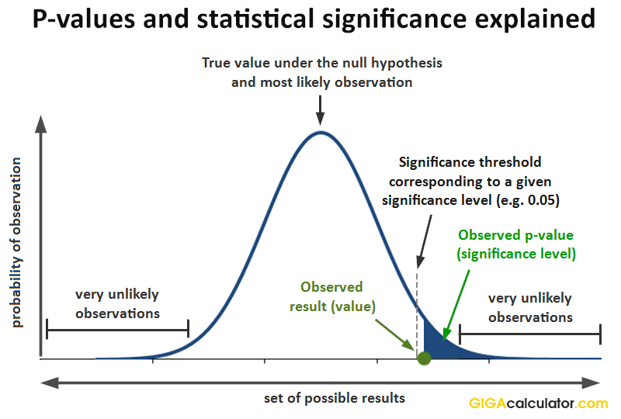

* **Decision :** reject null hypothesis if p-value is lower than the significance level, otherwise fail to reject null hypothesis.
* Easier to conduct hypothesis testing with p-value. No need to calculate t-statistics and remember different critical values.

1. **Hypothesis testing in Stata**

* Clear existing data

**clear**

* Create a dummy dataset

**set** seed 12345

**set** obs 100

**gen** group = mod(_n, 2)

**gen** **score** = 50 + group * 10 + rnormal(0, 10)

*conducting hypothesis testing

**ttest** **score** = 50 //H0: pop_mean = 50

**ttest** **score** = 55 //H0: pop_mean = 55

**ttest** **score** = 60 //H0: pop_mean = 60

* conducting two-sample t-test

**ttest** **score**, **by**(group) //H0: pop_mean_group1 = pop_mean_group2

//OR H0: pop_mean_group1 - pop_mean_group2 = 0

*Same answer can be obtained from regression

**reg** **score** group

***Exercise:***

Using NMICS6 data (hl.sav), conduct a hypothesis test whether average age between male and female is statistically different.

import spss "https://gitlab.com/misc.a/referenced/-/raw/main/NMICS6/hl.sav", **clear**

* HL6 -> Age, HL4 -> Sex

**sum** HL6 **if** HL4 == 1 //male : average age is 28.263

**sum** HL6 **if** HL4 == 2 //female : average age is 28.827

*Looks like the population means for male and female are not statistically different.

*Let's conduct the hypothesis testing

**ttest** HL6, **by**(HL4)

*Alternatively

**reg** HL6 HL4

1. **Hypothesis testing using non-parametric approach (bootstraping)**

**Bootstrap :** generating distribution of statistics of interest by resampling the sample with replacement. Using Bootstrap, we can calculate standard errors, confidence intervals, and other statistical measures.

**clear**

**set** seed 1

**set** obs 100

**gen** **score** = round(runiform() * 100)

* Bootstrap the median and test against a specified value (e.g., 50)

bootstrap **r**(p50), reps(1000): **summarize** **score**, detail

* Testing whether median is equal to 50 or not

**test** _bs_1 = 50

***Exercise:***

Using NMICS6 data (hl.sav), conduct a hypothesis test whether medeian age between male and female is statistically different.

import spss "https://gitlab.com/misc.a/referenced/-/raw/main/NMICS6/hl.sav", **clear**

**set** seed 12345

* Define a program to calculate the difference in medians

**program define** diff_medians, rclass

**summarize** HL6 **if** HL4 == 1, detail

**local** med0 = **r**(p50)

**summarize** HL6 **if** HL4 == 2, detail

**local** med1 = **r**(p50)

**return** **scalar** diff = `med1' - `med0'

**end**

* Bootstrap the difference in medians

bootstrap **r**(diff), reps(100): diff_medians

**Session 10: Regression analysis**

1. **Simple regression analysis**

**clear**

**set** seed 12345

**set** obs 100

**gen** study_hours = round(runiform() * 10)

**gen** **score** = 50 + 5 * study_hours + rnormal(0, 5)

**reg** **score** study_hours

1. **Multiple regression and diagnostics**

**clear**

**set** obs 200

**gen** age = mod(_n,52) + 18

**gen** educ_year = mod(_n,18)

* Generate Income variable with a positive relationship with Age and Education

**gen** income = 20000 + 800 * age + 3000 * educ_year + rnormal(0, 2000)

* Regression with omitted variable

**reg** income age

*******************************

* Residual diagnostics

*******************************

* Residual visual inspection

**rvfplot**

* Histogram plot for residual's distribution visualization

**predict** resid, residuals

**hist** resid

*Formal test of residuals normality

**swilk** resid

**drop** resid

* Multiple regression with correct specification

**reg** income age educ_year

*******************************

* residual diagnostics

*******************************

* Residual visual inspection

**rvfplot**

* Histogram plot for residual's distribution visualization

**predict** resid, residuals

**hist** resid

*Formal test of residuals normality

**swilk** resid

**Session 11: Advance regression with binary dependent variables (logit/probit)**

import spss "https://gitlab.com/misc.a/referenced/-/raw/main/NMICS6/hh.sav", **clear**

* dropping missing values

**drop** **if** missing(HHSEX)

* checking levels of HHSEX (Household Head Sex)

**codebook** HHSEX

**label** **list** labels410

**gen** hh_size = HH48 //HH member size variable

**gen** urb_rur = HH6 //1=Urban 2=Rural

**gen** province = HH7 //province number

* generating binary dependent variable separately

**gen** hhsex_male = 1

**replace** hhsex_male = 0 **if** HHSEX == 2 //1=Male 2=Female

*running logistic regression

**logit** hhsex_male hh_size ib1.urb_rur ib3.province

margins, **dydx**(hh_size urb_rur province)

* Similar results can be obtained using probit

* Running probit regression

**probit** hhsex_male hh_size ib1.urb_rur ib3.province

margins, **dydx**(hh_size urb_rur province)

**Session 12: Time series analysis**

1. **Stationarity concept**

* Stationarity refers to a time series whose statistical properties, such as mean, variance, and autocorrelation, remain constant over time.
* Non-stationary series are prone to spurious relationships.

1. **Spurious relationship**

**clear**

**set** seed 1

**set** obs 100

**gen** **year** = 1900 + _n

**tsset** **year**

**gen** ice_cream_sales = **year**\*10 + rnormal(0, 50)

**gen** shark_attacks = **year**\*5 + rnormal(0, 20)

* visual inspection for stationarity

twoway line ice_cream_sales **year**, name(ice_cream_sales, **replace**)

twoway line shark_attacks **year**, name(shark_attacks, **replace**)

**dfuller** ice_cream_sales //H0 : Non-stationary

**dfuller** shark_attacks //H0 : Non-stationary

* Run the initial regression (spurious relationship)

**reg** shark_attacks ice_cream_sales

1. **Making series stationary to avoid spurious relationship**

*****************************

* Making Series Stationary

*****************************

* Differencing variable makes series stationary

* If a variable is stationary at first difference, then its called

* I(1). I(0) means the variable is stationary at level.

twoway line D.ice_cream_sales **year**, name(ice_cream_sales, **replace**)

twoway line D.shark_attacks **year**, name(shark_attacks, **replace**)

**dfuller** D.ice_cream_sales //H0 : Non-stationary

**dfuller** D.shark_attacks //H0 : Non-stationary

*no relationship observed after differencing

**reg** D.shark_attacks D.ice_cream_sales

** log difference is preferred over simple difference as

** interpretation of coefficient becomes easier.

**gen** lshark_attacks = **log**(shark_attacks)

**gen** lice_cream_sales = **log**(ice_cream_sales)

twoway line D.lice_cream_sales **year**, name(ice_cream_sales, **replace**)

twoway line D.lshark_attacks **year**, name(shark_attacks, **replace**)

**dfuller** D.lice_cream_sales //H0 : Non-stationary

**dfuller** D.lshark_attacks //H0 : Non-stationary

**reg** D.lshark_attacks D.lice_cream_sales

1. **Example of non-stationary series with actual relationship**

**clear**

**set** seed 1

**set** obs 100

**gen** **year** = 1900 + _n

**tsset** **year**

**gen** income = **year**\*10 + rnormal(0, 50)

**gen** expenditure = income*0.5 + rnormal(0, 20)

* visual inspection for stationarity

twoway line income **year**, name(income, **replace**)

twoway line expenditure **year**, name(expenditure, **replace**)

**dfuller** income //H0 : Non-stationary

**dfuller** expenditure //H0 : Non-stationary

* Run the initial regression

**reg** expenditure income

*****************************

* Making Series Stationary

*****************************

**gen** lincome = **log**(income)

**gen** lexpenditure = **log**(expenditure)

* visual inspection for stationarity

twoway line D.lincome **year**, name(income, **replace**)

twoway line D.lexpenditure **year**, name(expenditure, **replace**)

**dfuller** D.lincome //H0 : Non-stationary

**dfuller** D.lexpenditure //H0 : Non-stationary

* Run the regression at first difference

**reg** D.lexpenditure D.lincome